**A**

**Mini Project Report**

**(Project Based Learning- KCS-551 Database Management System Lab)**

**on**

**GROCERY MART**

**Submitted in partial fulfilment of the requirements**

**for the award of the degree of**

**Bachelor of Technology**

**in**

**Computer Science and Engineering**

**By**

**Vandita Singh Gautam 1900970100125**

**TanishkMerothiya 1900970100114**

**Shiv Chandra Yadav 1900970100109**

**Vikas Kumar Bedi 1900970100127**

**Under the Guidance of**

**Mr. MAYANK DIXIT**



**DEPARTMENT OF COMPUTER SCIENCE AND ENGINEERING**

**GALGOTIAS COLLEGE ENGINEERING AND TECHNOLOGY,**

**GREATER NOIDA,India-201306**



**AFFILIATED TO**

**DR.A.P.J ADUL KALAM TECHNICAL UNIVERSITY,LUCKNOW ,UP**

**(Formerly UPTU)**

**GALGOTIAS COLLEGE OF ENGINEERING & TECHNOLOGY**

**GREATER NOIDA, UTTER PRADESH, INDIA- 201306 .**

### CERTIFICATE

This is to certify that the mini-project report entitled “**Grocery Mart** ” submitted by **Ms. Vandita Singh Gautam(1900970100125) , Mr. Tanishk Merothiya(1900970100120) , Mr. Vikas Kumar Bedi (1900970100127) , Mr. Shiv Chandra Yadav(1900970100109)** to the Galgotias College of Engineering & Technology, Greater Noida, Utter Pradesh, affiliated to Dr. A.P.J. Abdul Kalam Technical University Lucknow, Uttar Pradesh in partial fulfillment for the award of Degree of Bachelor of Technology in Computer science & Engineering is a bonafide record of the project work carried out by them under my supervision during the year 2021-2022.

**Mr. Mayank Dixit (Project Coordinator) Deptt. of CSE**

**Dr. Vishnu Sharma Professor and Head Deptt. of CSE**

**GALGOTIAS COLLEGE OF ENGINEERING & TECHNOLOGY**

**GREATER NOIDA, UTTER PRADESH, INDIA- 201306 .**

### ACKNOWLEDGEMENT

We have taken efforts in this project. However, it would not have been possible without the kind support and help of many individuals and organizations. We would like to extend my sincere thanks to all of them.

We are highly thankful to them for providing necessary information regarding the project & also for their support in completing the project.

We are extremely indebted to Dr. Vishnu Sharma, HOD, Department of Computer Science and Engineering, GCET and **<Mr. Mayank Dixit>**, Project Coordinator, Department of Computer Science and Engineering, GCET for their valuable suggestions and constant support throughout my project tenure. We would also like to express our sincere thanks to all faculty and staff members of Department of Computer Science and Engineering, GCET for their support in completing this project on time.

We also express gratitude towards our parents for their kind co-operation and encouragement which helped me in completion of this project. Our thanks and appreciations also go to our friends in developing the project and all the people who have willingly helped me out with their abilities.

(Vandita Singh)

(Tanishk Merothiya)

(Shiv Chandra )

(Vikas Kumar)

|  |  |
| --- | --- |
| **Table of Contents** | **Page**  **No.** |
| 1.0 Introduction |  |
| 1.1 Purpose |  |
| 1.2 Scope |  |
| 1.3 Overview |  |
| 1.4 Goals of Proposed System |  |
| 1.5 Background |  |
| 1.6 Project Requirements |  |
| 1.7 Technologies Used |  |
| 1.8 User Characteristics |  |
| 1.9 Constraints |  |
| 1.10 Definition of Problems |  |
| 2.0 Feasibility Study |  |
| 2.1 Technical Feasibility |  |
| 2.2 Economical Feasibility |  |
| 2.3 Operational Feasibility |  |

|  |  |
| --- | --- |
| 2.4 Schedule Feasibility |  |
| 3.0 System Analysis |  |
| 3.1 Working of Present System |  |
| 3.2 Disadvantages of Present System |  |
| 3.3 Proposed System |  |
| 3.4 Architectural Design |  |
| 3.5 Data Flow Diagram |  |
| 3.6 Use Case Model |  |
| 3.7 System Design |  |
| 4.0 Software & Hardware Requirements |  |
| 5.0 Code & their Test Cases URL |  |
| 6.0 References |  |
| 7.0 Conclusion |  |

**Software Requirements Specifications**

**INTRODUCTION**

Purpose of the project

The Grocery Management System is developed to facilitate the work of the grocery storekeeper and the customer who buys the products. This system consists of the methods which can relate the perpetual crisis while managing the rhetoric quandaries concerning the authoritarian source. After the technological advancement in every sector, people are utilizing more and more machines which are deleterious for the environment and engendering hazardous situations for human lives.

Because of the sudden increase in the overall world’s pollution index now it’s not safe to buy victuals items which are making and selling in the open area or the street pabulum. This pabulum can make a person sick, he may suffer some diseases if he orally consumes the pollution-contaminated aliment.

It is rigorously exhorted to buy pabulum items either packed or from the stores which are not in an open area and following hygienic rules. We require aliment daily consequently to buy grocery is a customary task which people incline to do weekly or monthly as per their location and availability. The proposed system will avail the customer to opt for the type of grocery items he requires and forward the list to the admin then after the admin suggest a team and pack the items and then the distribution person distributes them to the doorstep of the customer.

The customer doesn’t need to visit the store, cull the items from the shelves, and then to buy groceries. Now he can just get it by the avail of the system, he just needs to access his account or if he is an incipient user then first he requires registering himself into the system so that the data of him is perpetually stored in the database of the system. It will be auxiliary when the customer authenticates again then he doesn’t need to lodge his details because the system can retrieve it within the database quandary.

The system is very active and covers all the necessary options which are needed by the admin and customer even if there is some error that occurs in the system then it sends an alert mail to the admin or the concerning department. The following are the concerning points of this system which are considered:

The system is proactive and performs the task which is necessary sometimes even for the troubleshoots.

The clause of this system handles many customers at the same time and provides smooth functioning with a better and enhanced user interface.

The admin can perform tasks to handle the customer as well as the staff of the store.

The authorized person can edit, delete, and modify the sustaining database as and when required.

It monitors the actions of the customer and suggests him better products from the system interface.

**Obsolete System:**

People need to buy the grocery at a fine-tuned interval of time, there are some items which can be purchased for utilizing it more than a week but withal there are many items which need to be utilized on the same day or within 2-3 days like dairy products, etc. if the customer is a working person then he has to first schedule his timing to go for grocery shopping then after making the list of sundry items, he goes to the market where he visits many shops to buy items because all items are not available in the same street shop.

This process requires adscititious physical effort and time to buy the grocery, it’s a very tiring and hectic method plus a person needs to reiterate it every week or month as per the requisite. Sometimes due to lack of time people buy victuals items from nearby street shops of the roadside areas then after consuming they get sick and many diseases follow it.

The owner keeps the record of the transaction on papers and then he forefends the papers punctiliously but there are many chances of error to occur while maintaining the records additionally if someone wants to find any record then he has to check all the papers. If there is any kind of error occurs afore then it is very arduous to track the error on the papers.

Apart from maintaining the record, there is so much other information which the owner needs to take care and indicted it down somewhere consequently a systematic management system is needed to clear out all the possible quandaries as well as managing the day to day transaction and data. The sundry points which are weakening the current system are:

* The information or the data recorded in the papers are less trustable because there may be so many problems occur while managing the record papers.
* This system contains many errors and there is no method through which we can track the error if any occurs.
* The owner cannot keep an eye on every transaction that happens in a day with the customer.
* This system has also required the efforts of the customer as he has to come to the store and then select items and buy them himself.
* To keep the information of the store staff, it requires great efforts and time to write down each staffs data.

**Required System:**

A centralized system is needed to store the data and information of every customer and staff in an automated manner so that we can retrieve the data whenever required. This system is created by keeping in mind the difficulties and problems of the owner and the customer as well. This system is error-free, reliable, and efficient enough to control the flow of data and store it in a systematic manner.

The system bifurcates the data in product type, size, variety, quantity, brand manner also there are many types of items available in the groceries like wheat, rice, pulses, sugar, and other household edible items.

It can easily run all the work simultaneously without error and technical glitches. The admin customer and the staff can work after logging into their respective accounts. The interface of all three is given according to the need and requirement of the entity it has separated options as well.

The admin controls the data of the customers and also the staff member’s data along with their salary structure, the designation of every staff. It provides full control of the system to the admin.

Here the customer can select the items and save them in the online cart in the system and pays the estimated amount through online options after receiving the request the admin gathers the staff of particular racks and instruct them to pack those items, thereafter the delivery boy deliver the items at the customer’s residence as per his given time and date. The following are the key points of this system:

* All the data is in an automated form where we can track any information if required.
* The employees can see the data of the respective customer if there’s any error occurs and reported by the customer.
* It is a unified system that can work simultaneously and saves data according to the department and account in the database.
* There are separate sections through which the customer can find any item or product by entering the title of it.
* The admin can track the delivery person and guide him towards the customer’s residence.

**About:**

The Grocery Shopping System keeps track of all information about a product, including its manufacturer, type, customer, and stock. This system can also maintain track of the personal information of customers.The grocery shopping system is a PHP and SQL-based online application. It allows you to manage your grocery store, customer information, and assist in the online sale of your groceries.

**Objective:**

This project's main purpose is to maintain track of all the information about the different stores, their selling products, customer information, and order information. This system also aids in the management of grocery inventory, restocking, sales, refunds, purchases, and other tasks. It increases the number of employment available and the number of opportunities to participate in earning activities.

**CHAPTER 2: REQUIREMENTS**

**Functional Requirements**

The functional requirements are those requirements that are necessary to the eye of the user and the client. Here we try to make the module possible to accomplish the need of the desired function.A few of its functional requirements are as follows:

**Non-Functional Requirements of Glossary Management System: –**

These requirements need unit among the style of “system shall be,” overall associated property of the regime as a full or of an individual aspect and not an individual operates. The system’s overall properties remarkably mark the excellence between whether or not the event project has succeeded or unsuccessful.

Unit of measurement usually divided into two broad categories:

* Execution qualities, like security and quality, that unit evident at the runtime.
* Evolution qualities, like liabilities, maintainability, flexibility, and quantitative, that unit embodied among the static structure of the code.

The non-functional grocery management system needs to place restrictions on the merchandise being developed, the event technique, and specify external constraints that the merchandise has to be compelled to meet. Our project qualifies all the factors of helpful and nonhelpful consequently and the system is up to mark performance device.

Here we’d prefer to need the care of few lots of things before heading towards the system. The many sensible, intuitive interfaces are usually created. That ultimately build an interface easy to use for a lengthy time. In distinction to ancient vogue wherever the goal is to build the difficulty or application physically enticing, the purpose of interface trend is to build the user’s interaction expertise as straightforward and intuitive as double – what’s typically mentioned as user-centered fashion.

Where smart graphic/industrial fashion is daring and eye-catching, intelligent interface fashion is sometimes delicate and invisible

**2.2 System Requirements**

(System requirements are the building blocks developers use to build the system)

|  |  |  |
| --- | --- | --- |
| **Category** | **Minimum** | **Maximum** |
| OPERATING SYSTEM: | Windows 10 is used as it is stable and supports more features and is more user friendly | Windows 10 and above |
| ENVIRONMENT: | Microsoft Visual Studio | 2019 version 12.7 |
| .NET FRAMEWORK: | PHP | Version 4.5.2 |
| LANGUAGE: | CSS, HTML,PHP | Net brans IDE 7.0.2 or Eclipse Neon. |
| BACKEND: | SQL |  |

**HARDWARE REQUIREMENT:**

|  |  |  |  |
| --- | --- | --- | --- |
| **Category** | **Minimum** | **Maximum** | |
|  |  | Windows | MAC OS X |
| PROCESSOR: | Intel Pentium III | Intel Core i5 and above ( Intel Core i7) OR AMD FX 4100 and above, or A6 and above | |
| HARD DISK: | 20GB | 128 Gigabytes (GB)* | 128GB+Solid State Disk(SSD) with at least 20 GB of free disk space |
| RAM: | 1GB | 8GB | |
| PROCESSOR SPEED: | 2.4 GHz |  |  |
| Wired Networking: | Ethernet LAN Port or USB | Ethernet LAN Port or USB Ethernet Adapter/Dongle | |
| Intra server | |
| Wireless Networking | 802.09g | 802.13ax | |

**DESIGN**

Schema Design & Schema Diagram (LOGICAL DESIGN)

**Data Dictionary**

*(description of each table and its attributes)*

SET SQL_MODE = "NO_AUTO_VALUE_ON_ZERO";

SET AUTOCOMMIT = 0;

START TRANSACTION;

SET time_zone = "+00:00";

CREATE TABLE `admin` (

`adm_id` int(222) NOT NULL,

`username` varchar(222) NOT NULL,

`password` varchar(222) NOT NULL,

`email` varchar(222) NOT NULL,

`code` varchar(222) NOT NULL,

`date` timestamp NOT NULL DEFAULT CURRENT_TIMESTAMP ON UPDATE CURRENT_TIMESTAMP

) ENGINE=InnoDB DEFAULT CHARSET=latin1;

INSERT INTO `admin` (`adm_id`, `username`, `password`, `email`, `code`, `date`) VALUES

(6, 'admin', '81dc9bdb52d04dc20036dbd8313ed055', 'admin@gmail.com', '', '2018-04-09 07:36:18'),

(8, 'abc888', '6d0361d5777656072438f6e314a852bc', 'abc@gmail.com', 'QX5ZMN', '2018-04-13 18:12:30');

CREATE TABLE `admin_codes` (

`id` int(222) NOT NULL,

`codes` varchar(6) NOT NULL

) ENGINE=InnoDB DEFAULT CHARSET=latin1;

INSERT INTO `admin_codes` (`id`, `codes`) VALUES

(1, 'QX5ZMN'),

(2, 'QFE6ZM'),

(3, 'QMZR92'),

(4, 'QPGIOV'),

(5, 'QSTE52'),

(6, 'QMTZ2J');

CREATE TABLE `items` (

`d_id` int(222) NOT NULL,

`rs_id` int(222) NOT NULL,

`title` varchar(222) NOT NULL,

`slogan` varchar(222) NOT NULL,

`price` decimal(10,2) NOT NULL,

`img` varchar(222) NOT NULL

) ENGINE=InnoDB DEFAULT CHARSET=latin1;

INSERT INTO `items` (`d_id`, `rs_id`, `title`, `slogan`, `price`, `img`) VALUES

(19, 54, 'Rice', 'Get your high quality rice here', '45.00', '60d7304382141.png'),

(20, 54, 'Urad Dhall', 'Make your dishes delicious with urad dhall', '130.00', '60d731f8c88be.jpg'),

(21, 54, 'Jaggery', 'Be healthy, Eat well', '60.00', '60d732525b06e.jpg'),

(22, 54, 'Red chilly', 'Make your dishes spicy', '150.00', '60d7333478564.jpg'),

(23, 58, 'Groundnut', 'Get the best groundnut from us', '100.00', '60d80a2f549c5.jpg'),

(24, 58, 'Moong Dhall', 'Fine grains for better eating', '150.00', '60d80a179cf88.jpg'),

(25, 58, 'Millet', 'Quality assured', '40.00', '60d80a0519a93.jpg'),

(26, 59, 'wheat', 'A true delight for the taste buds', '40.00', '60d809f58a62a.jpg'),

(27, 59, 'Rice Flakes', 'love every bite', '30.00', '60d809d216776.jpg'),

(28, 59, 'Millet Vermicelli', 'Feel the difference when you eat', '52.00', '60d809ac4c442.jpg'),

(31, 61, 'Chenna', 'Makes you healthy and happy', '55.00', '60d822c9c4a54.jpg'),

(32, 61, 'Maize', 'Classic quality', '60.00', '60d822e8ad30a.jpg');

CREATE TABLE `remark` (

`id` int(11) NOT NULL,

`frm_id` int(11) NOT NULL,

`status` varchar(255) NOT NULL,

`remark` mediumtext NOT NULL,

`remarkDate` timestamp NOT NULL DEFAULT CURRENT_TIMESTAMP

) ENGINE=InnoDB DEFAULT CHARSET=latin1;

INSERT INTO `remark` (`id`, `frm_id`, `status`, `remark`, `remarkDate`) VALUES

(62, 32, 'in process', 'hi', '2018-04-18 17:35:52'),

(63, 32, 'closed', 'cc', '2018-04-18 17:36:46'),

(64, 32, 'in process', 'fff', '2018-04-18 18:01:37'),

(65, 32, 'closed', 'its delv', '2018-04-18 18:08:55'),

(66, 34, 'in process', 'on a way', '2018-04-18 18:56:32'),

(67, 35, 'closed', 'ok', '2018-04-18 18:59:08'),

(68, 37, 'in process', 'on the way!', '2018-04-18 19:50:06'),

(69, 37, 'rejected', 'if admin cancel for any reason this box is for remark only for buterperposes', '2018-04-18 19:51:19'),

(70, 37, 'closed', 'delivered success', '2018-04-18 19:51:50'),

(71, 39, 'in process', 'on the way', '2021-06-26 05:19:09'),

(72, 39, 'closed', 'D', '2021-06-26 05:19:30'),

(73, 40, 'in process', 'ready', '2021-06-26 13:29:17'),

(74, 51, 'closed', 'Your product delivered', '2021-06-27 03:18:31'),

(75, 57, 'in process', 'Your order is on the way', '2021-06-27 06:38:52'),

(76, 58, 'closed', 'we delivered your order', '2021-06-27 06:39:28'),

(77, 59, 'rejected', 'Currently not available', '2021-06-27 06:39:57'),

(78, 60, 'closed', 'delivered', '2021-06-27 07:08:25'),

(79, 61, 'in process', 'on the way', '2021-06-27 07:08:56'),

(80, 62, 'rejected', 'Currently unavailable', '2021-06-27 07:09:29');

CREATE TABLE `store` (

`rs_id` int(222) NOT NULL,

`c_id` int(222) NOT NULL,

`title` varchar(222) NOT NULL,

`email` varchar(222) NOT NULL,

`phone` varchar(222) NOT NULL,

`url` varchar(222) NOT NULL,

`o_hr` varchar(222) NOT NULL,

`c_hr` varchar(222) NOT NULL,

`o_days` varchar(222) NOT NULL,

`address` text NOT NULL,

`image` text NOT NULL,

`date` timestamp NOT NULL DEFAULT CURRENT_TIMESTAMP ON UPDATE CURRENT_TIMESTAMP

) ENGINE=InnoDB DEFAULT CHARSET=latin1;

INSERT INTO `store` (`rs_id`, `c_id`, `title`, `email`, `phone`, `url`, `o_hr`, `c_hr`, `o_days`, `address`, `image`, `date`) VALUES

(54, 0, 'Velan Store', 'velan@example.com', '+91 97845231', 'http://velan.example', '7am', '8pm', '24hr-x7', ' 12, abc street, West Bengal, India ', '60d6e9391a2b6.png', '2021-06-26 08:45:45'),

(58, 0, 'Grocery Wala', 'grocerywala@example.com', '9784512601', 'http://grocerywala.com', '9am', '7pm', 'mon-sat', ' 34, muktha street, West Bengal, India ', '60d8096bc6c6d.png', '2021-06-27 05:15:23'),

(59, 0, 'Organic Grocery', 'orgogrocery@example.com', '8754213265', 'http://orgogrocery.example', '9am', '8pm', 'mon-fri', '13, sanco street, Trichy', '60d8072125c35.png', '2021-06-27 05:05:37'),

(61, 0, 'Mini Metro', 'minimetro@example.com', '9784125013', 'http://minimet.com', '8am', '8pm', '24hr-x7', '19, mark street, india', '60d822940ec56.jpg', '2021-06-27 07:02:44');

CREATE TABLE `users` (

`u_id` int(222) NOT NULL,

`username` varchar(222) NOT NULL,

`f_name` varchar(222) NOT NULL,

`l_name` varchar(222) NOT NULL,

`email` varchar(222) NOT NULL,

`phone` varchar(222) NOT NULL,

`password` varchar(222) NOT NULL,

`address` text NOT NULL,

`status` int(222) NOT NULL DEFAULT '1',

`date` timestamp NOT NULL DEFAULT CURRENT_TIMESTAMP ON UPDATE CURRENT_TIMESTAMP

) ENGINE=InnoDB DEFAULT CHARSET=latin1;

INSERT INTO `users` (`u_id`, `username`, `f_name`, `l_name`, `email`, `phone`, `password`, `address`, `status`, `date`) VALUES

(31, 'mahesh', 'navon', 'singh', 'manasi@gm.co', '9147852369', '658fdb54cd6f53be7429195ffad38801', 'badri col phase 2', 1, '2021-06-27 00:17:57'),

(32, 'navjot890', 'nav', 'singh', 'nds949405@gmail.com', '6232125458', '6d0361d5777656072438f6e314a852bc', 'badri col phase 1', 1, '2018-04-18 09:50:56'),

(33, 'rock', 'rock1', 'rock2', 'rock@gm.co', '1234567891', '983772fb9d34ee820b4fac9b62625e0b', 'ddfs', 1, '2021-06-26 04:54:49'),

(34, 'mikel', 'jon', 'kin', 'mjk@exampl.com', '9547210356', '60b889fc5594ef0979ce89e86a5dfca3', '48, sms street, Trichy, india', 1, '2021-06-27 00:19:42'),

(35, 'vishnu', 'vishnu', 'priya', 'vishnupriya@exm.com', '75315984620', '04f2eae8bb201945960a9385717a60d1', '21, kali street, india', 1, '2021-06-27 06:36:40'),

(36, 'Vishnupriya', 'vishnupriya', 'dharshini', 'vish@gm.com', '7532146820', '81bfac29cb35d7915bfbbf638230aa78', '28, kamaraj street, india', 1, '2021-06-27 07:06:21');

CREATE TABLE `users_orders` (

`o_id` int(222) NOT NULL,

`u_id` int(222) NOT NULL,

`title` varchar(222) NOT NULL,

`quantity` int(222) NOT NULL,

`price` decimal(10,2) NOT NULL,

`status` varchar(222) DEFAULT NULL,

`date` timestamp NOT NULL DEFAULT CURRENT_TIMESTAMP ON UPDATE CURRENT_TIMESTAMP

) ENGINE=InnoDB DEFAULT CHARSET=latin1;

INSERT INTO `users_orders` (`o_id`, `u_id`, `title`, `quantity`, `price`, `status`, `date`) VALUES

(60, 36, 'Maize', 2, '60.00', 'closed', '2021-06-27 07:08:25'),

(61, 36, 'Rice', 1, '45.00', 'in process', '2021-06-27 07:08:56'),

(62, 36, 'Millet Vermicelli', 2, '52.00', 'rejected', '2021-06-27 07:09:29'),

(64, 36, 'Maize', 2, '60.00', NULL, '2021-06-27 13:21:20'),

(65, 36, 'Rice', 1, '45.00', NULL, '2021-06-27 13:21:20'),

(66, 36, 'Millet Vermicelli', 2, '52.00', NULL, '2021-06-27 13:21:20'),

(67, 36, 'wheat', 1, '40.00', NULL, '2021-06-27 13:21:20');

ALTER TABLE `admin`

ADD PRIMARY KEY (`adm_id`);

ALTER TABLE `admin_codes`

ADD PRIMARY KEY (`id`);

ALTER TABLE `items`

ADD PRIMARY KEY (`d_id`);

ALTER TABLE `remark`

ADD PRIMARY KEY (`id`);

ALTER TABLE `store`

ADD PRIMARY KEY (`rs_id`);

ALTER TABLE `users`

ADD PRIMARY KEY (`u_id`);

ALTER TABLE `users_orders`

ADD PRIMARY KEY (`o_id`);

ALTER TABLE `admin`

MODIFY `adm_id` int(222) NOT NULL AUTO_INCREMENT, AUTO_INCREMENT=9;

ALTER TABLE `admin_codes`

MODIFY `id` int(222) NOT NULL AUTO_INCREMENT, AUTO_INCREMENT=7;

ALTER TABLE `items`

MODIFY `d_id` int(222) NOT NULL AUTO_INCREMENT, AUTO_INCREMENT=33;

ALTER TABLE `remark`

MODIFY `id` int(11) NOT NULL AUTO_INCREMENT, AUTO_INCREMENT=81;

ALTER TABLE `store`

MODIFY `rs_id` int(222) NOT NULL AUTO_INCREMENT, AUTO_INCREMENT=62;

ALTER TABLE `users`

MODIFY `u_id` int(222) NOT NULL AUTO_INCREMENT, AUTO_INCREMENT=37;

ALTER TABLE `users_orders`

MODIFY `o_id` int(222) NOT NULL AUTO_INCREMENT, AUTO_INCREMENT=68;

COMMIT;

**Populated snapshot of tables**

*Database - Grocery*

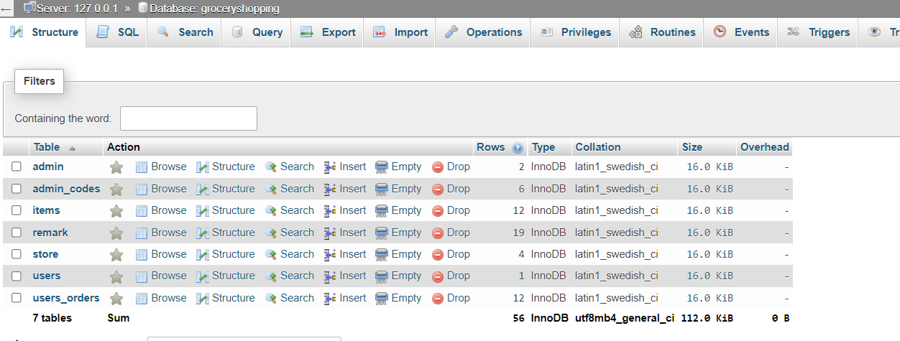

*Admin Table*

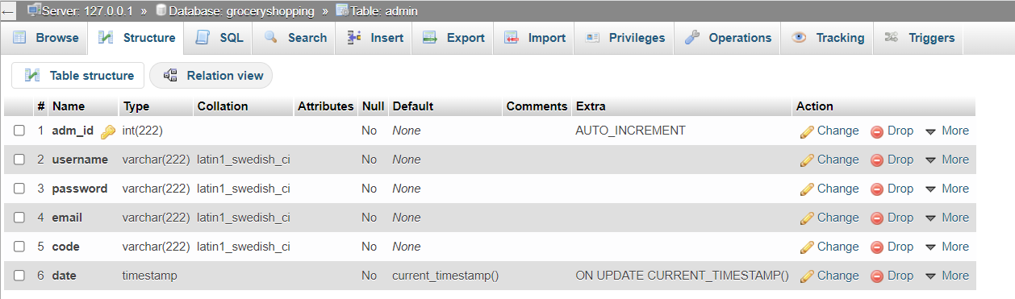

*Admin_codes Table*

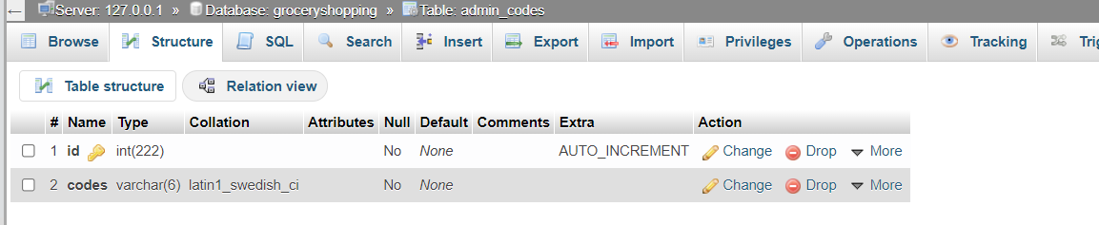

*Items Table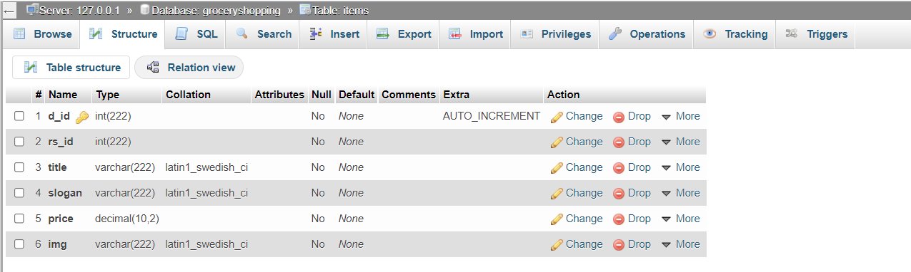Remarks Table*

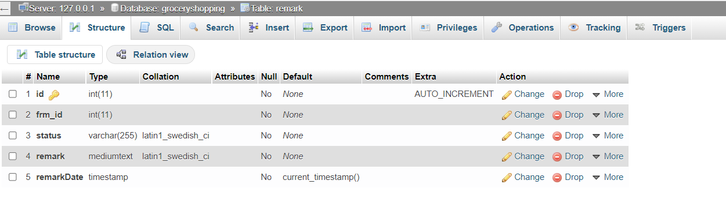

*Store Table*

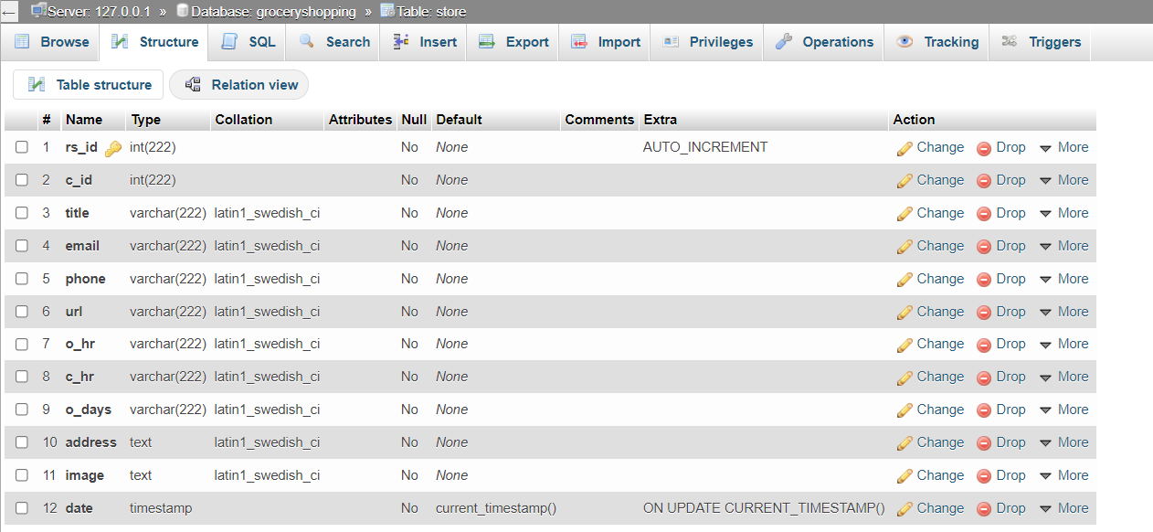

*User Table*

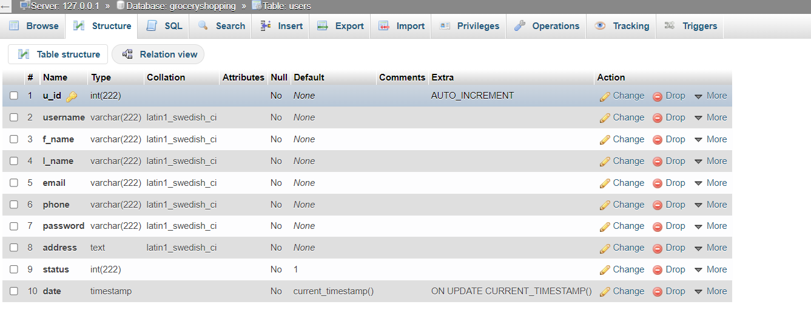

*User_orders Table*

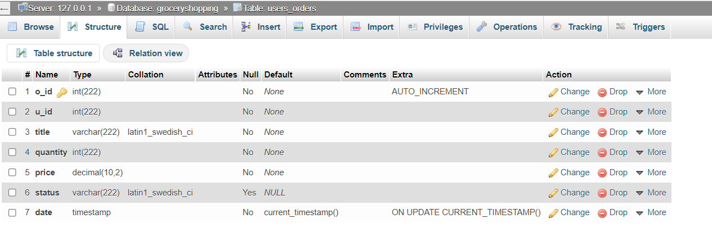

**Use Case Diagram:**

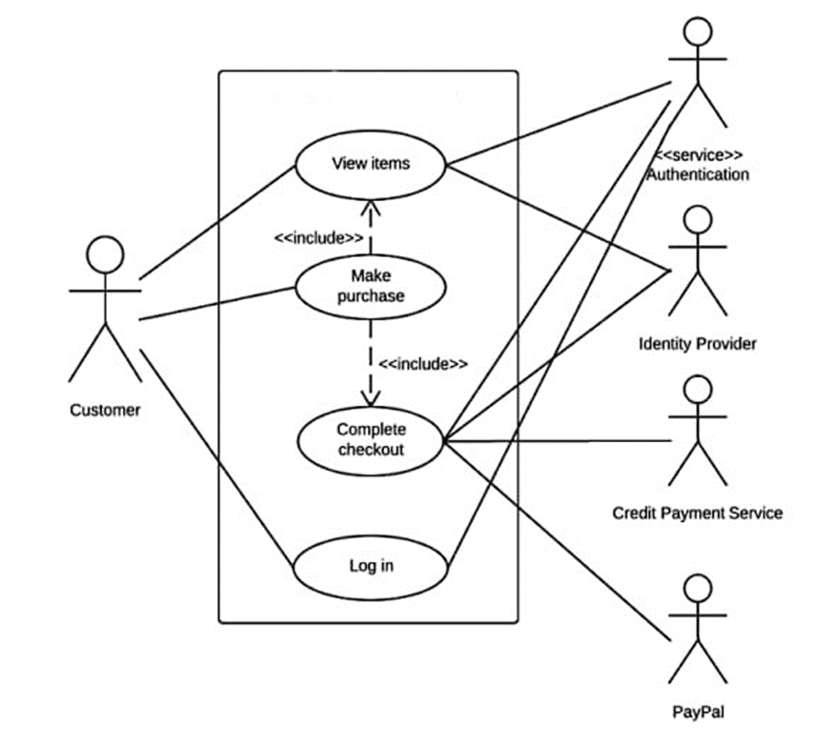

**Solution Architecture**

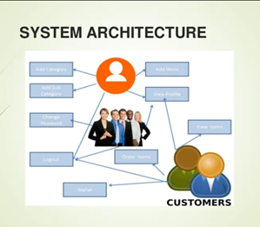

**USER INTERFACE**

**Screen Layout/SNAPSHOTS**



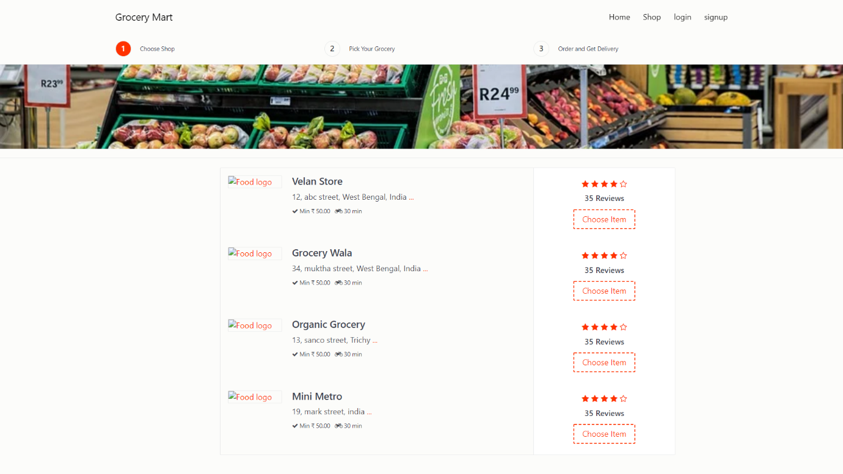

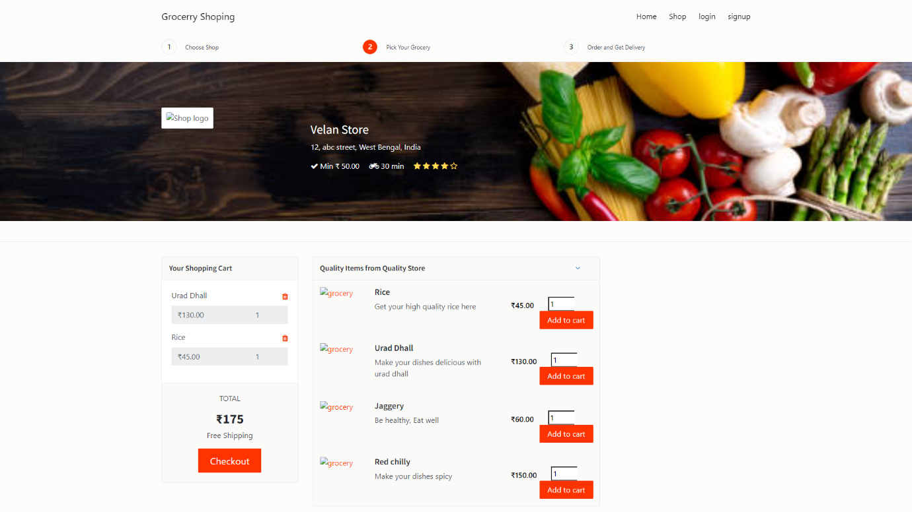

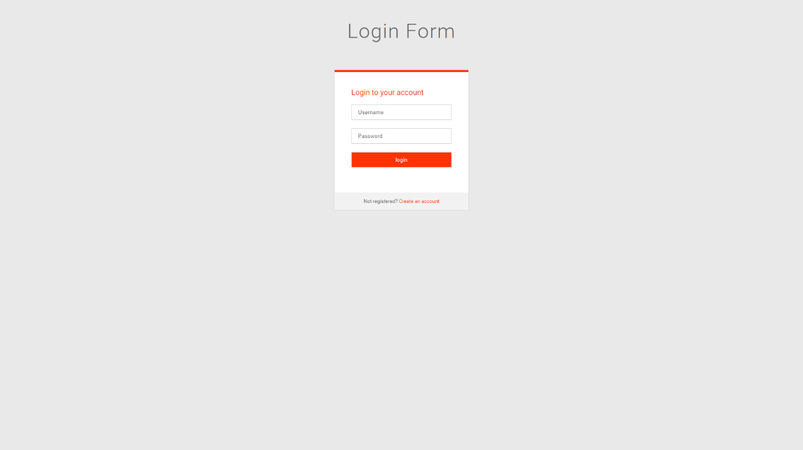

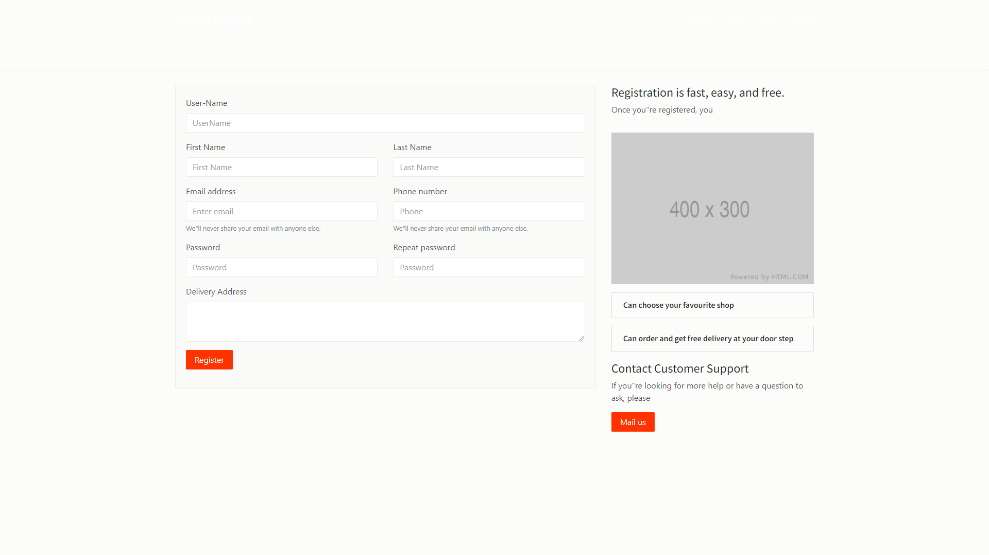

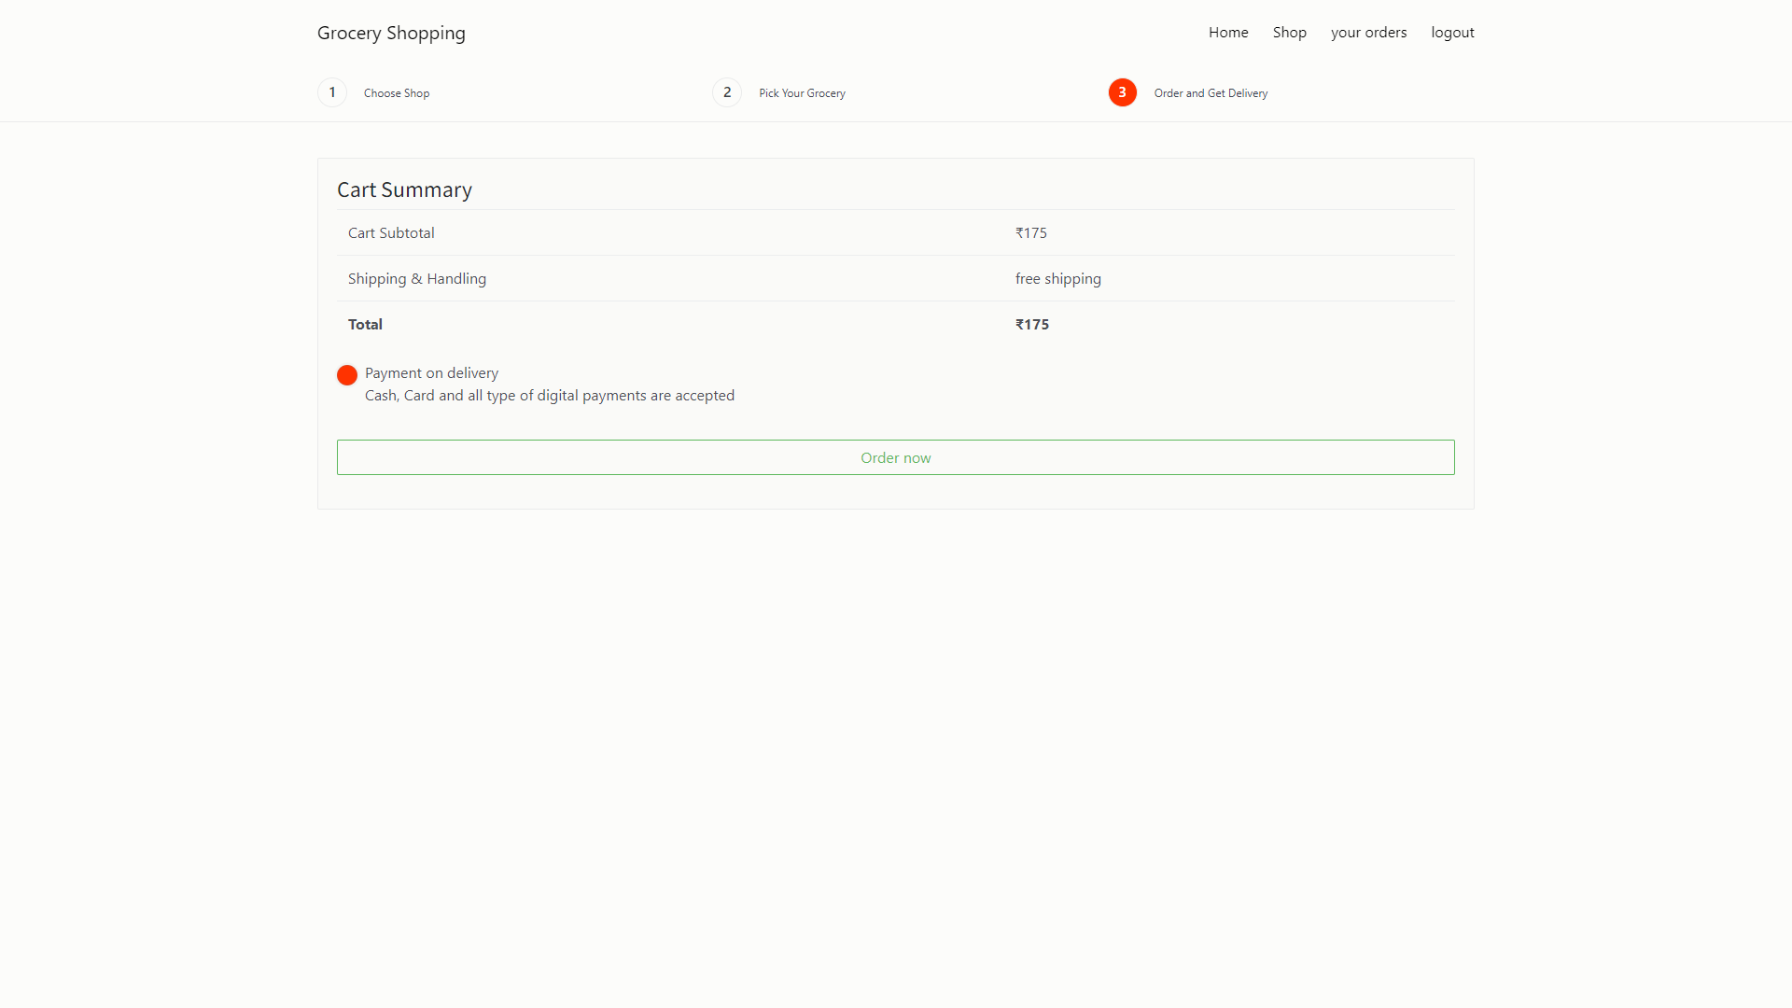

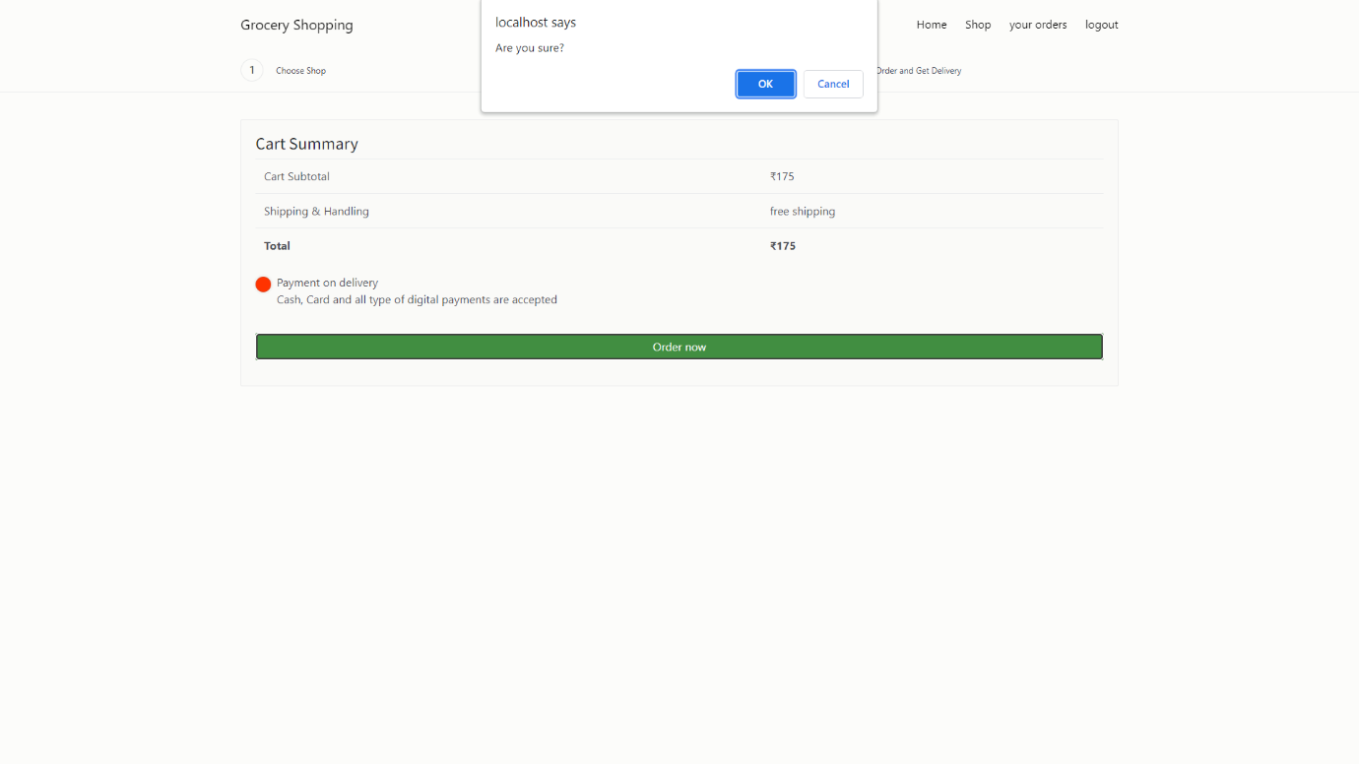

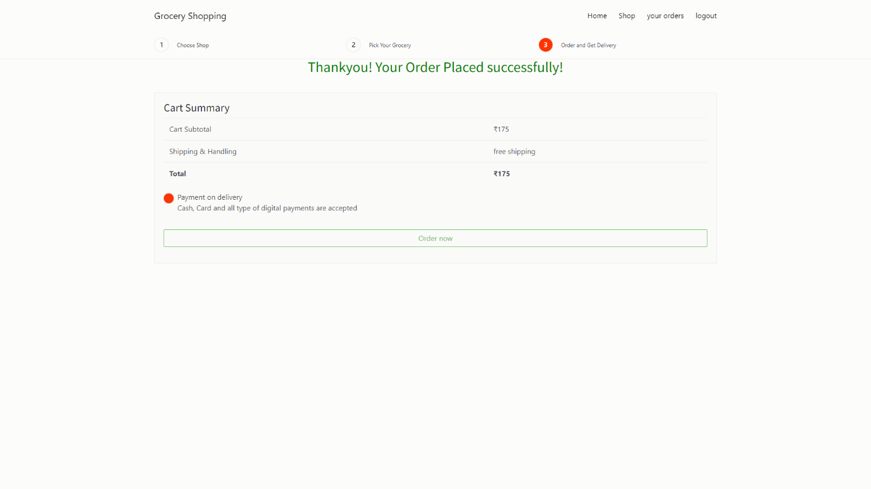

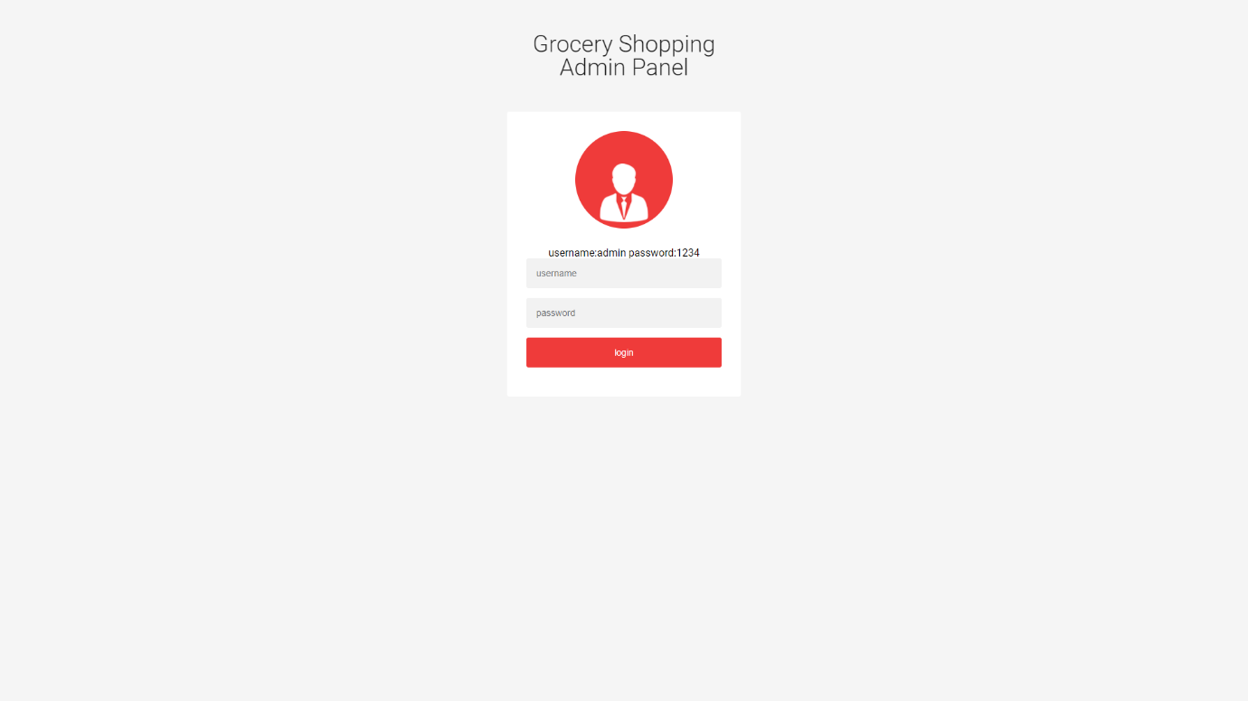

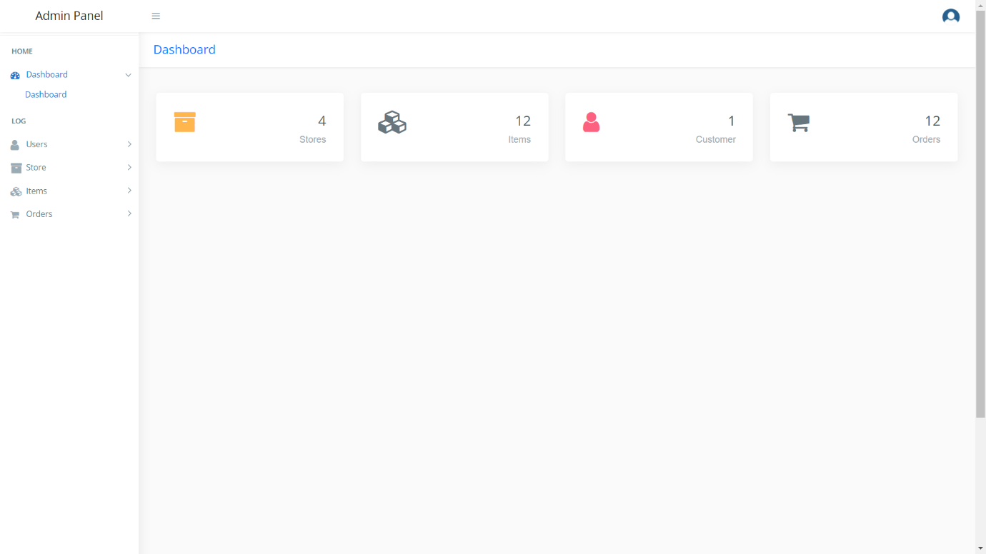

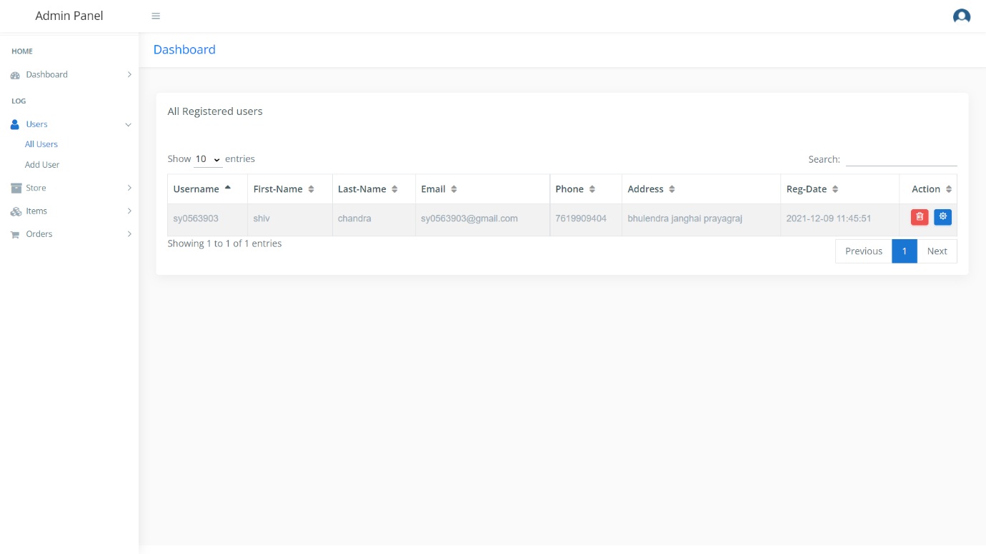

**Implementation**

**Module Description**

Admin Panel

Admin has the official powers to control the flow of the data from one part of the system to the other. He can manipulate the access of the users to the data. The primary purpose of this account is to make the user data relevant and then giving the inputs to the other interface module and make it work optimistically and get the timetable according to the wish we want to create for a particular type of inputs.

Hence all the data will be reflected in clean and well data in the interfaces.

(i) Dashboard

(ii) User Management

* Add User
* Update / Delete User

(iii) Store Management

* Add Store
* Update / Delete Store

(iv) Item Management

* Add Item to specific Store
* Update/ Delete Item

(v) Order Management

* Order Management
* Get all Order Details
* Take Action on Order
* Dispatch – For new order
* On the way – If the order ready for packing
* Cancelled – If the ordered item is unavailable

**Code Snippets**

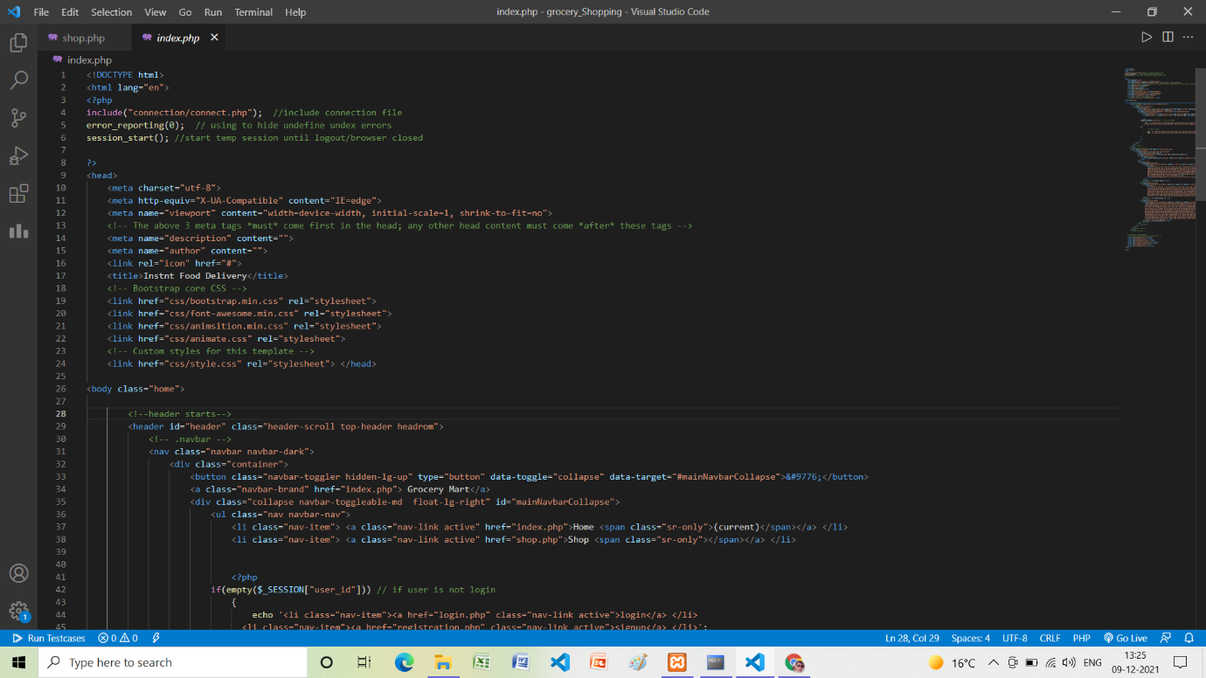

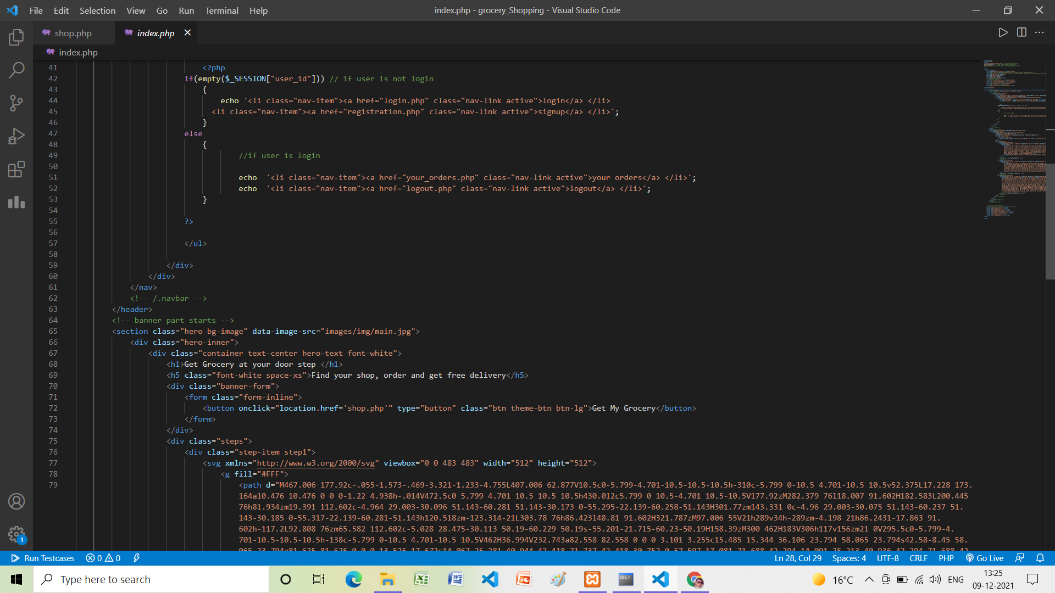

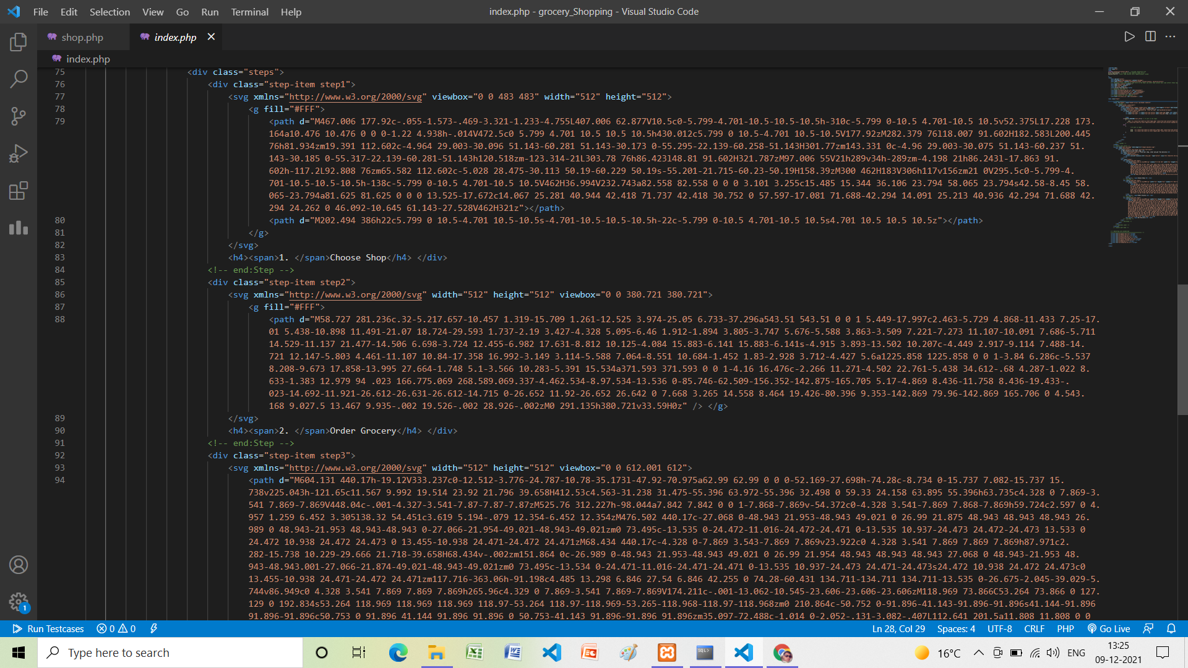

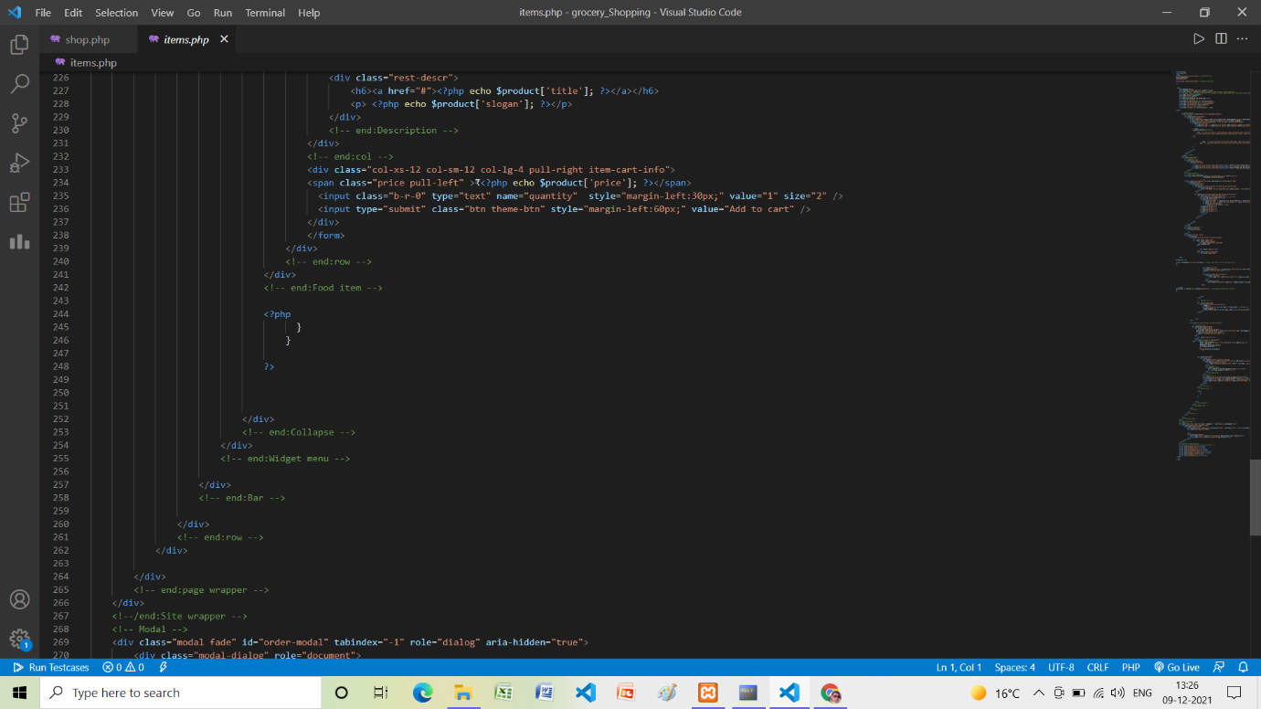

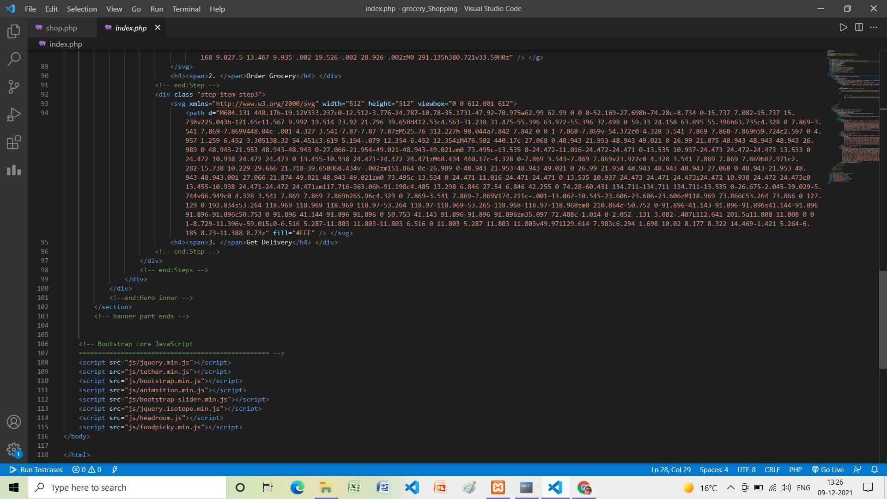

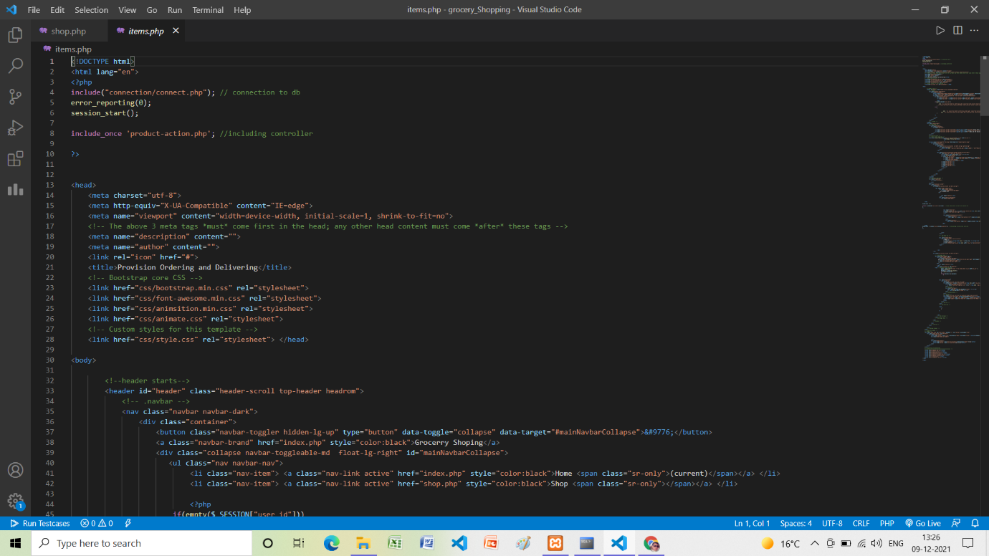

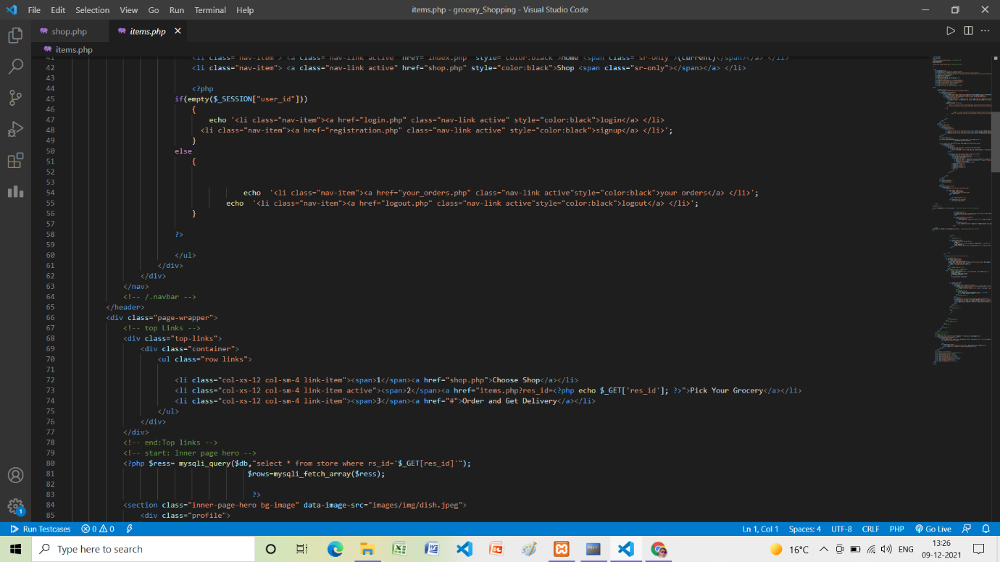

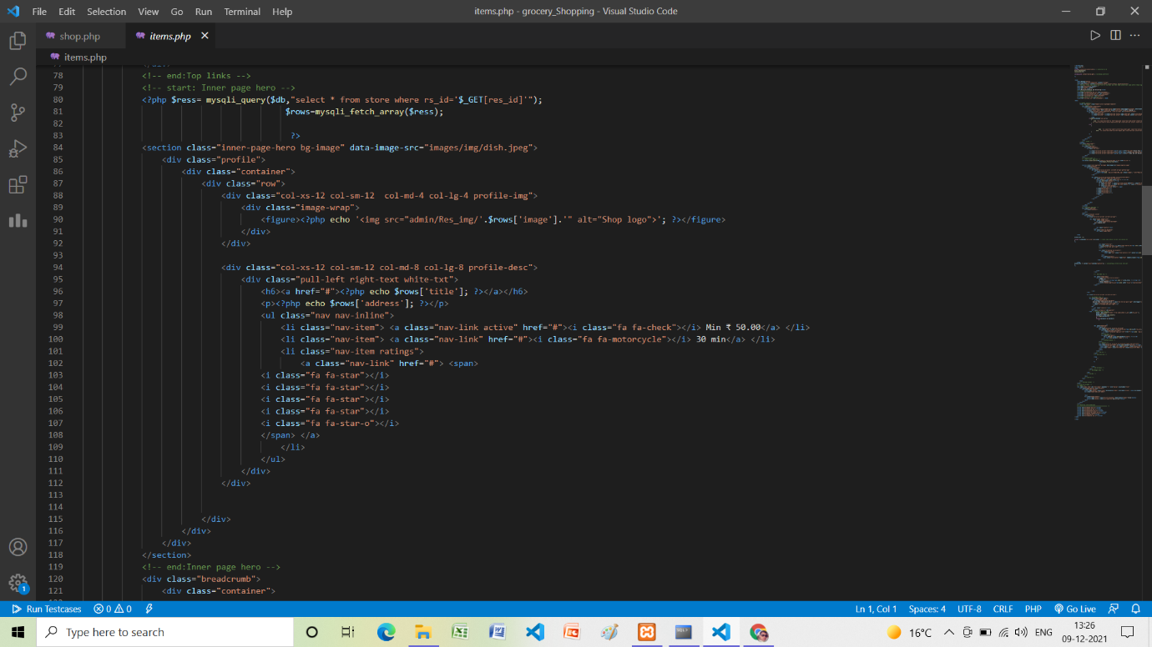

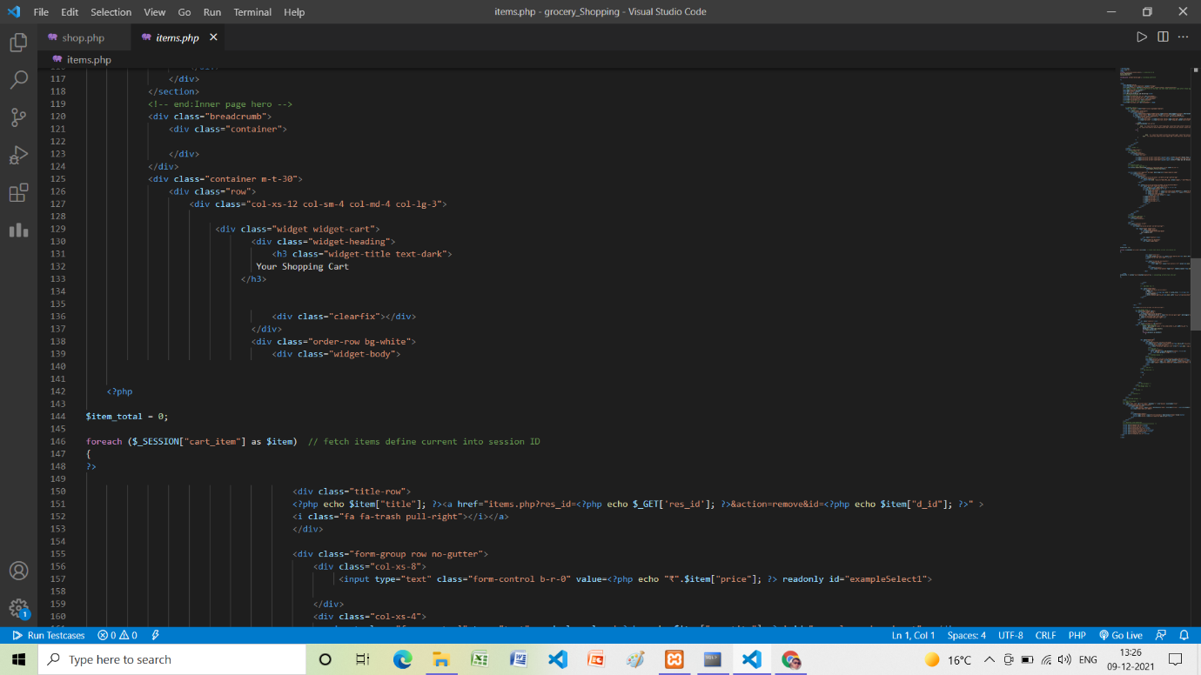

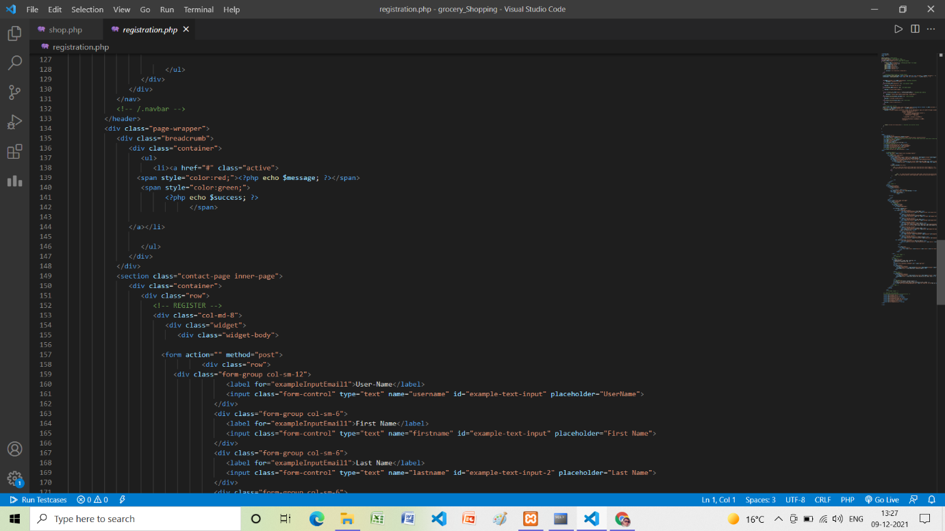

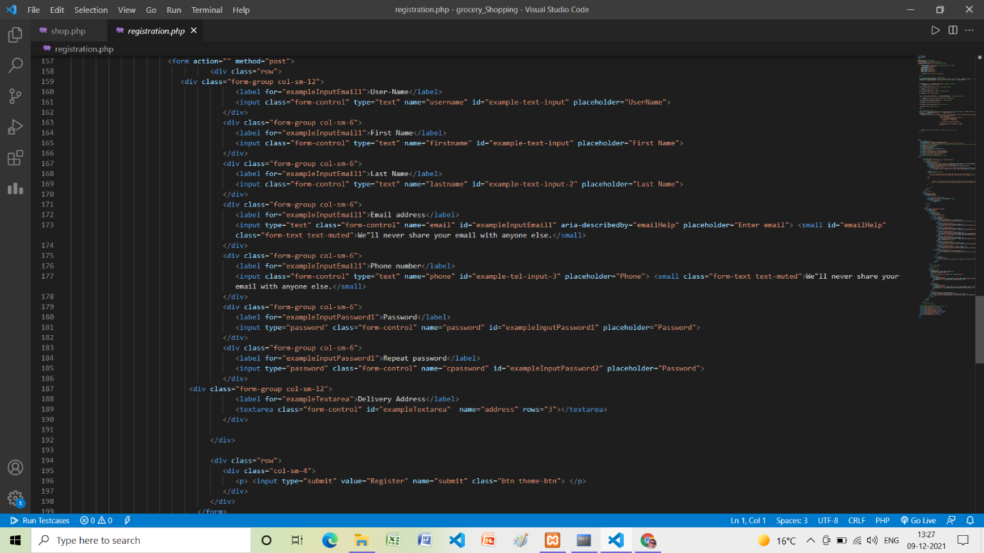

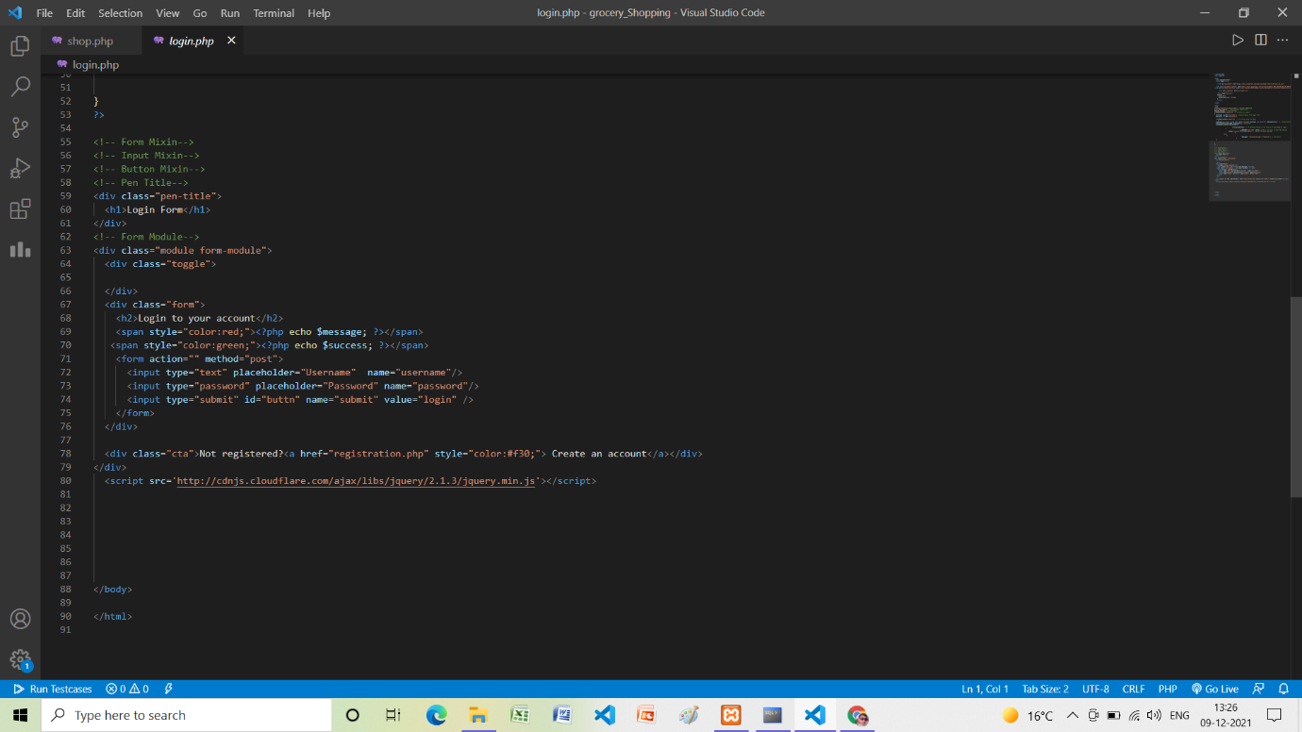

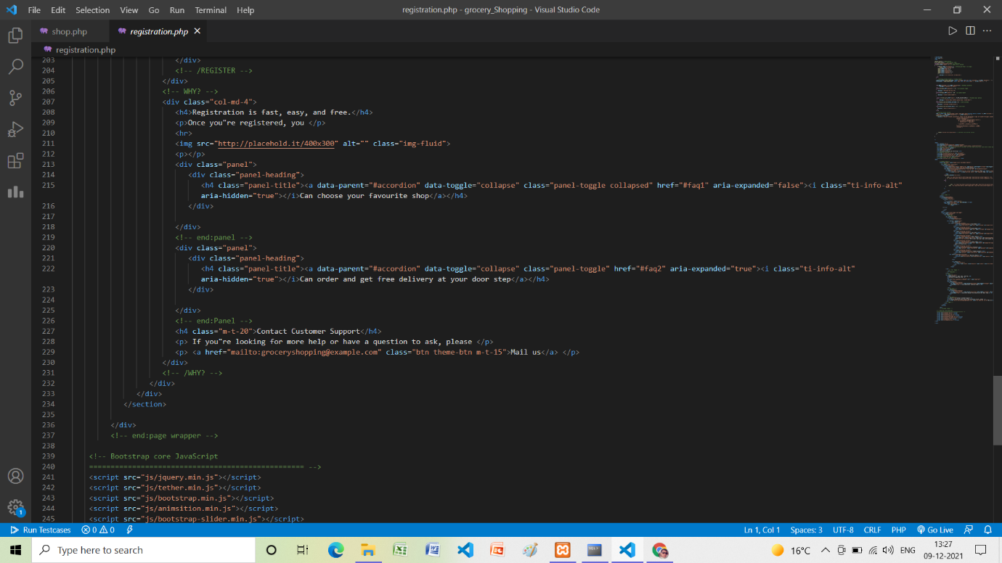

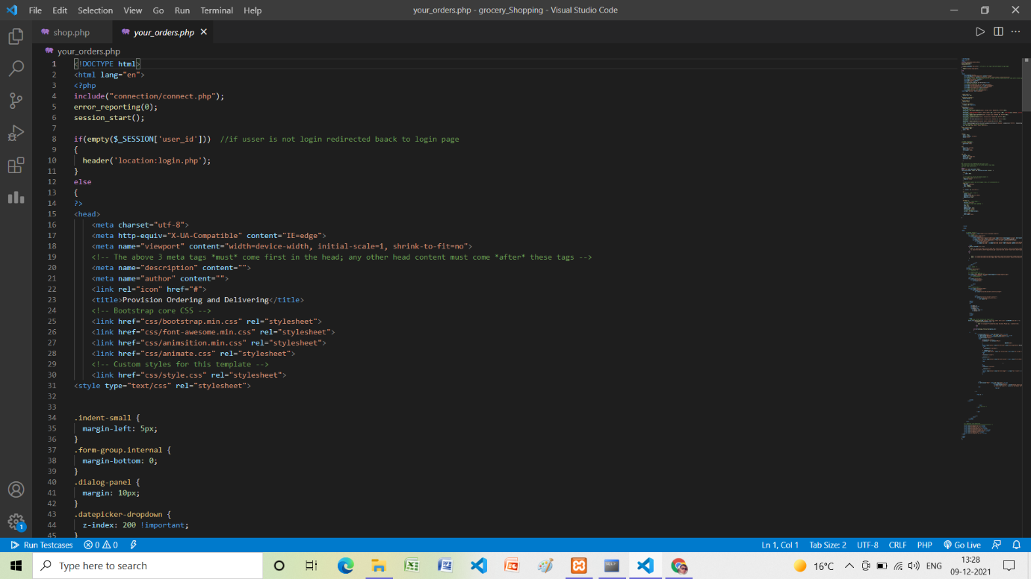

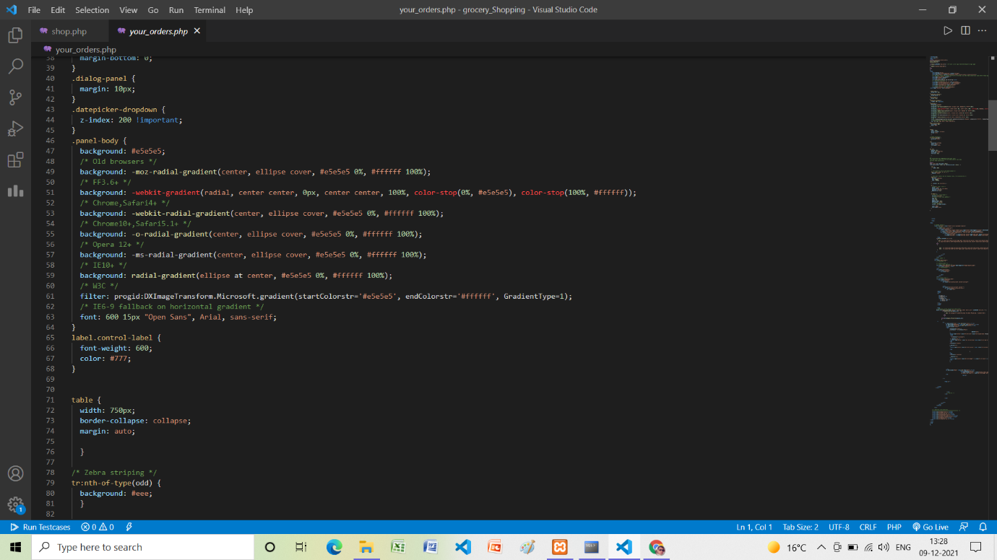

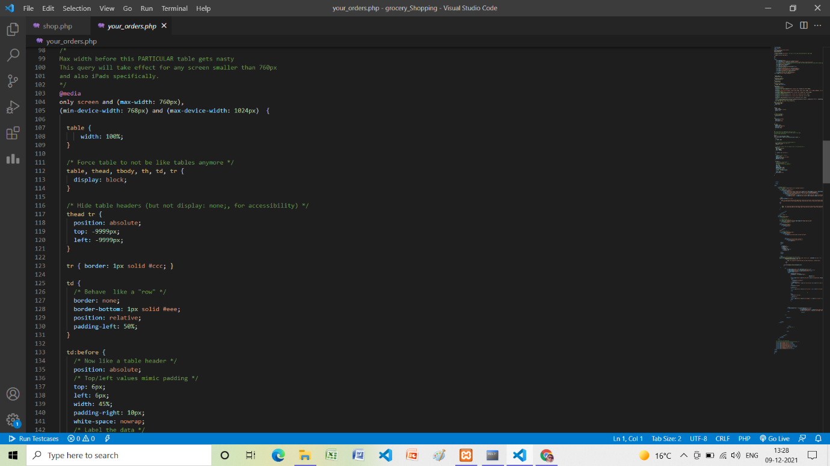

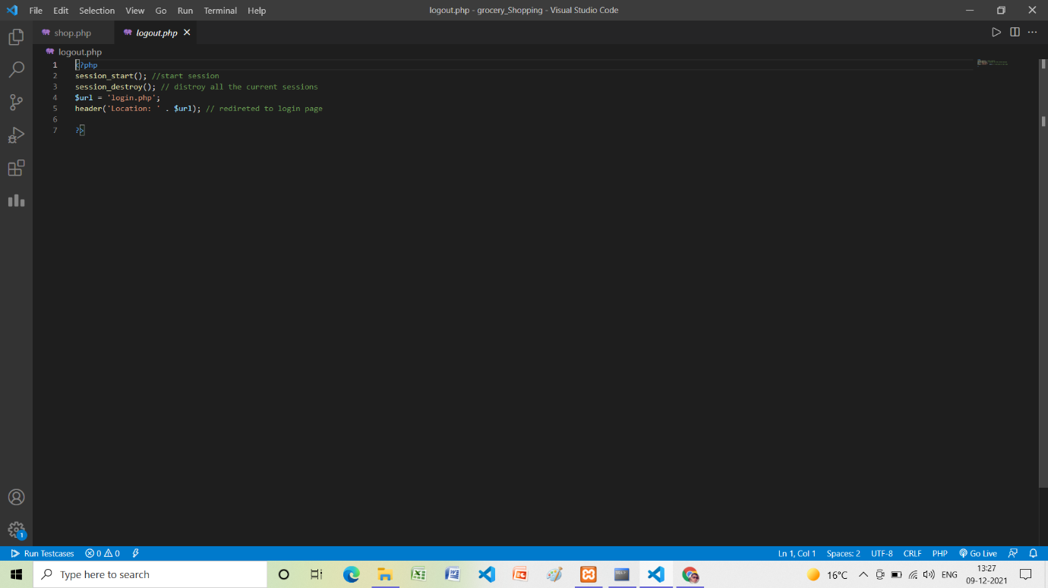

**Testing**

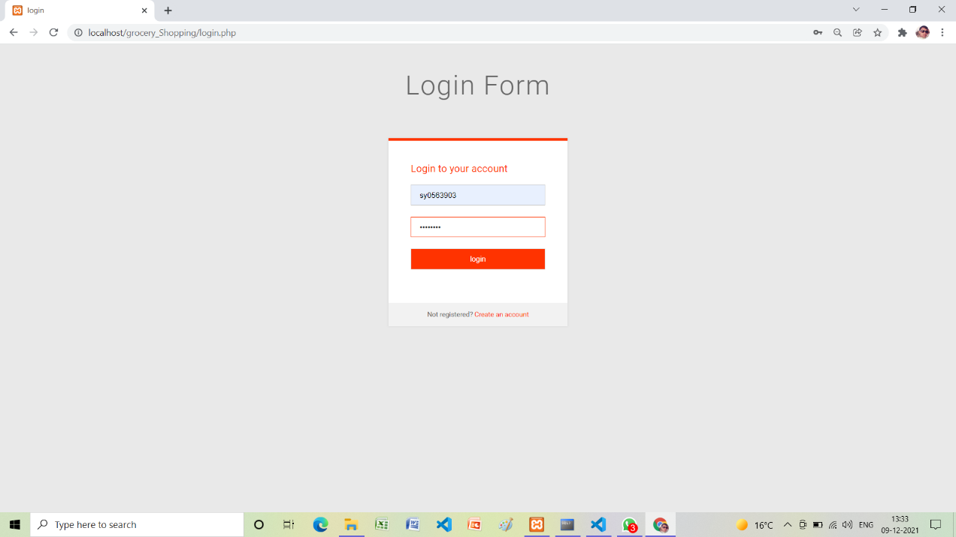

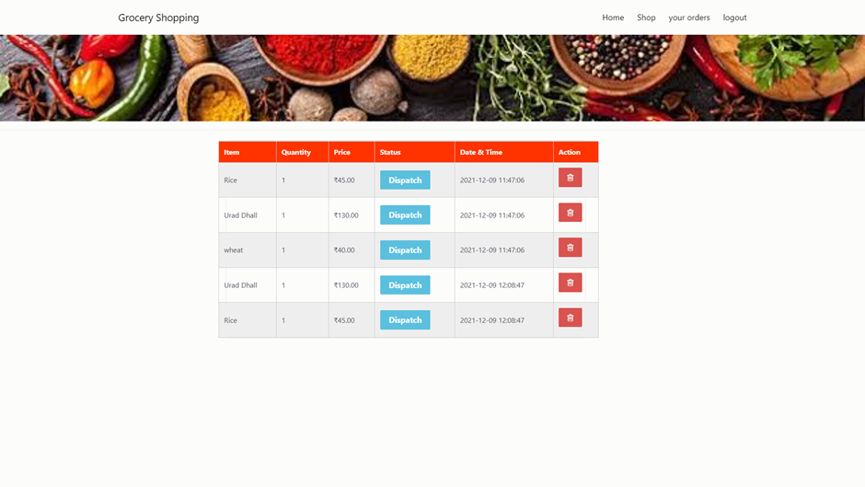

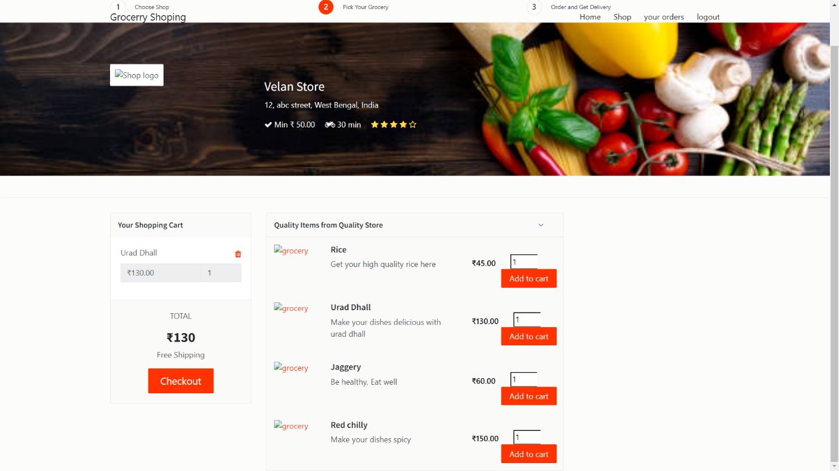

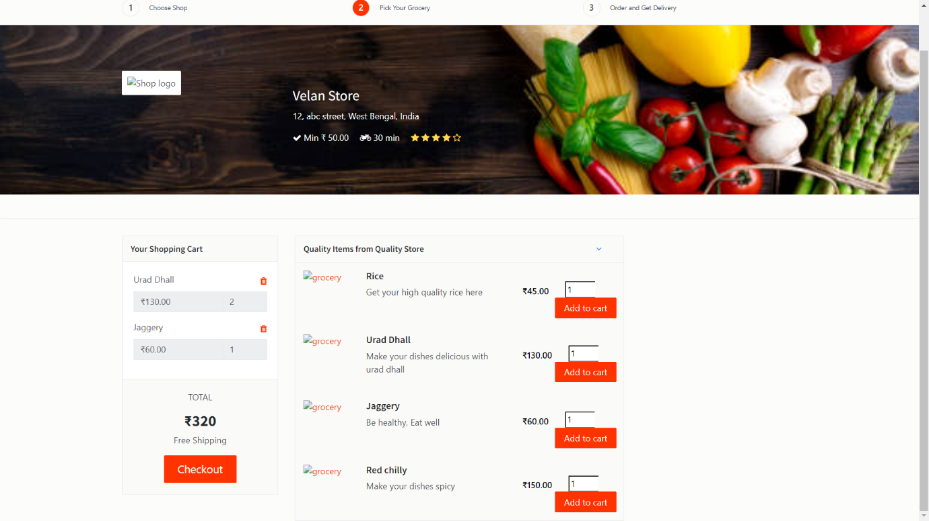

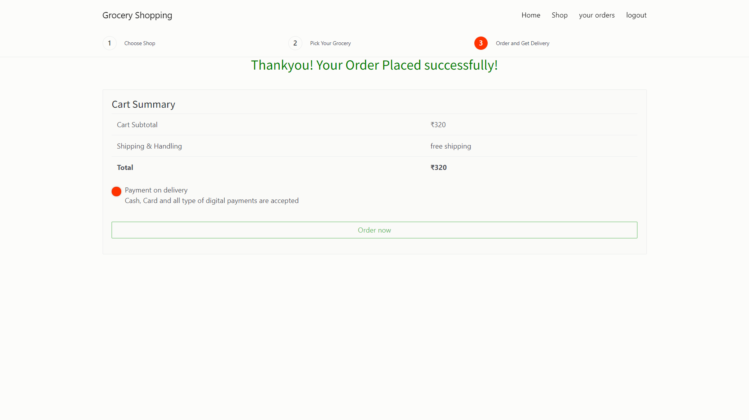

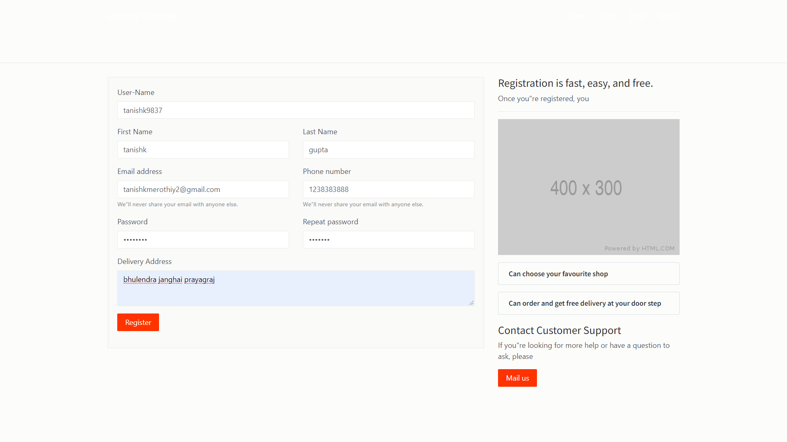

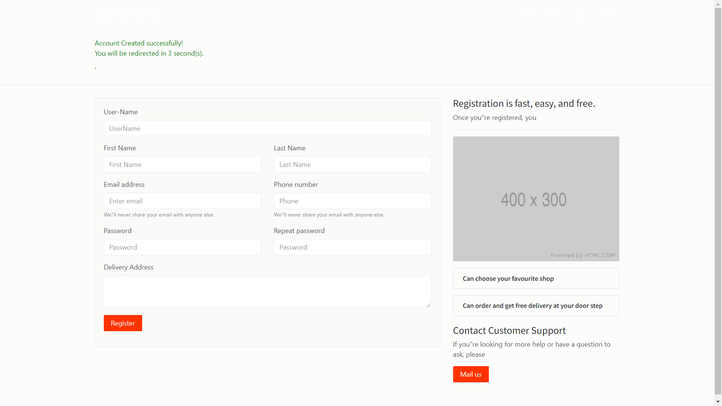

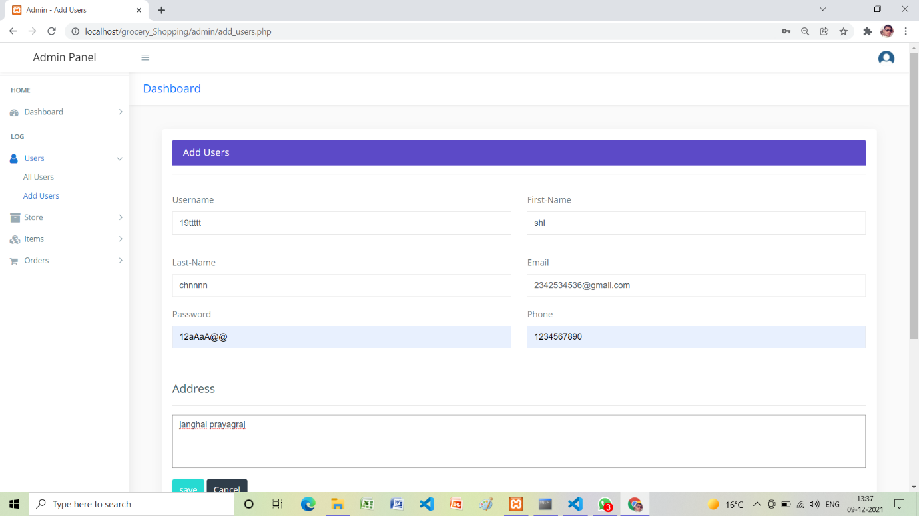

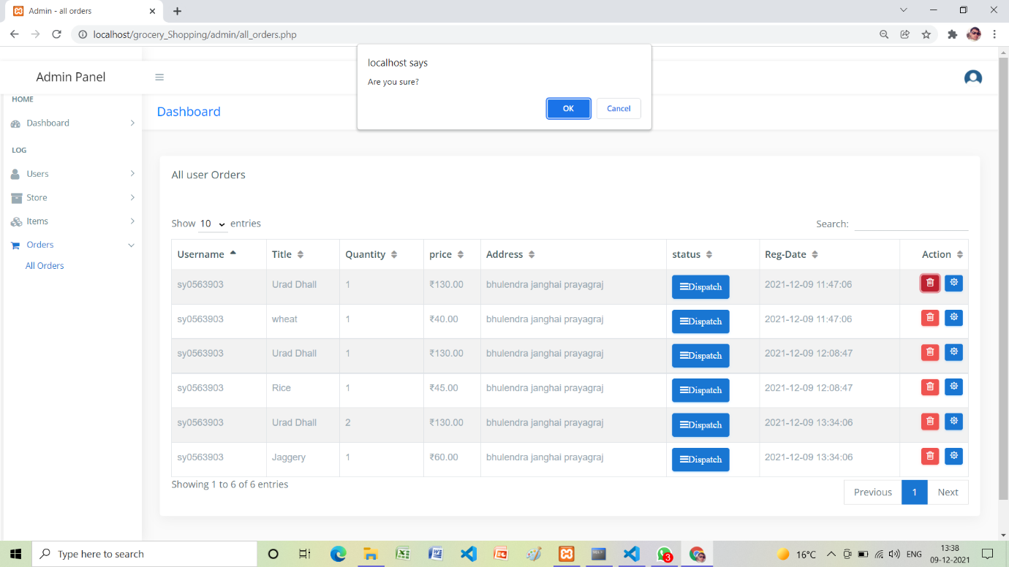

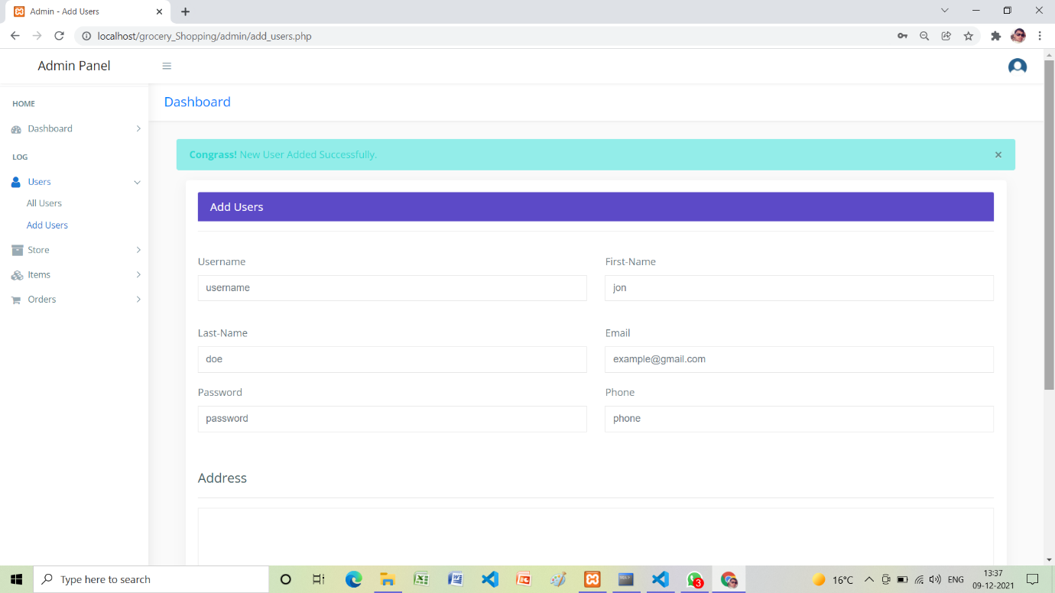

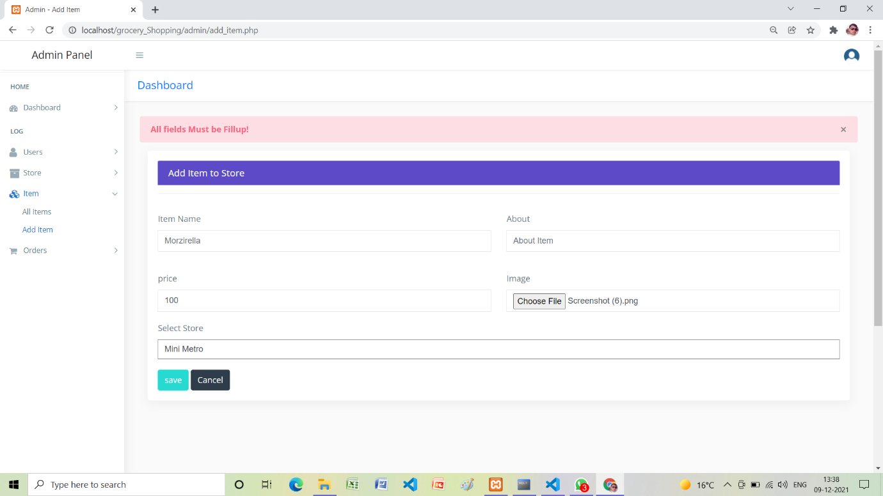

**Bibliography**

* + - HTML: Complete Reference
    - [www.w3schools.com](http://www.w3schools.com/)
    - [www.emurse.com](http://www.emurse.com/)
    - Various e-books and tutorials provided on Internet • [www.wikipedia.org](http://www.wikipedia.org/)
    - [www.webreference.com](http://www.webreference.com/)
    - [www.dynamicajax.com](http://www.dynamicajax.com/)
    - [www.webdesign.org](http://www.webdesign.org/)
    - [www.csstutorial.net](http://www.csstutorial.net/)
    - [www.photoshopsupport.com](http://www.photoshopsupport.com/)
    - [www.learn-sql-tutorial.com](http://www.learn-sql-tutorial.com/)
    - [www.learn-xml-tutorial.com](http://www.learn-xml-tutorial.com/)